Acceptance Tests planning and reception

During the course of these tests I will log in different account types and check that everything is in order and the acceptance criteria of the stories are fulfilled. To check that health and safety staff have the required abilities, I logged as one of them, I click on the add button to add or press the clear button to remove violations. Violations can be marked as resolved/completed. These were the acceptance criteria of Story 12: Health and Safety Notifications, and they have been fulfilled.

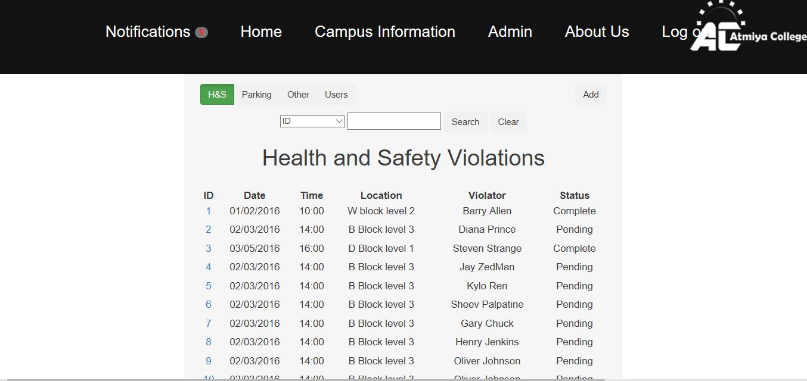

Story 6 Parking Violation checking acceptance criteria is met because parking officers can search and/or sort parking and other notifications by criteria (e.g. they go to bar with the id and they click on a different parameter to sort violations and also choose which type of violations they want to look at.

Story 28 Review Overdue Fines is complete because users that have a violation appears in red and after the fine is payed the violation is marked as resolved and becomes un-flagged.

Story 22 Error Correction acceptance criteria is complete because admins can check on parking permits and sort them and they sorted by most relevant.

Story 9 Fine Payment Checking acceptance criteria by clicking on the overdue status of violation and sends an email notification to the user.

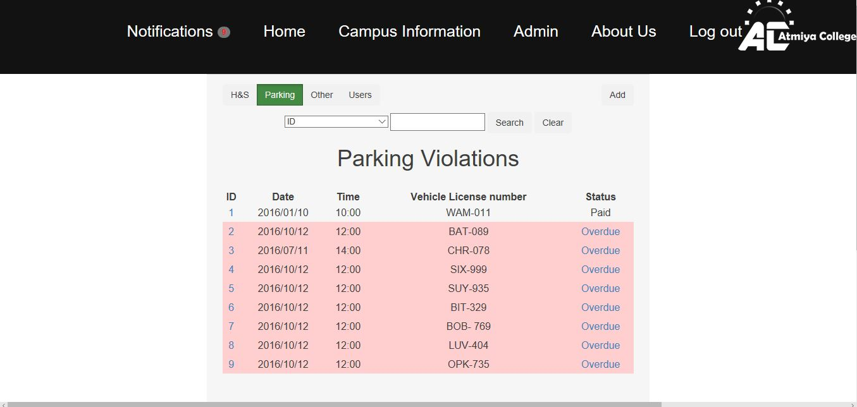

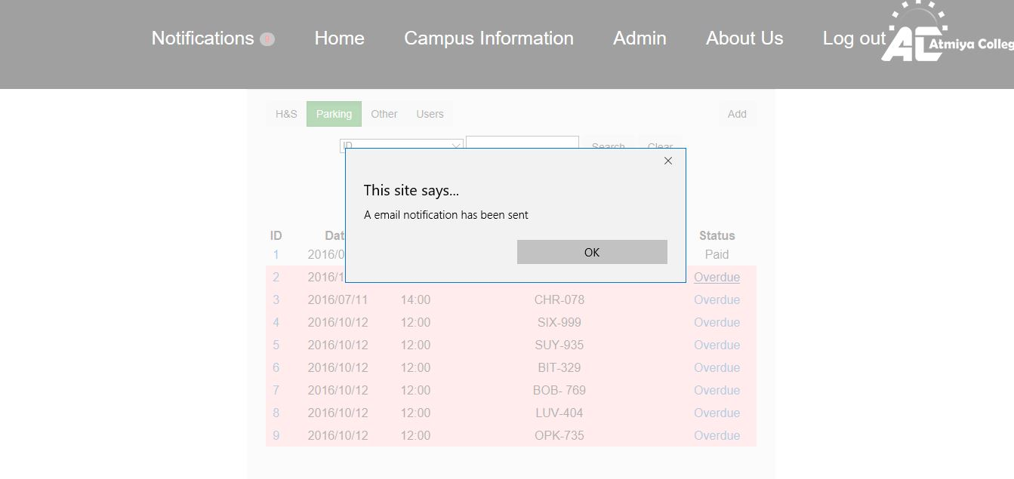

*Above screenshot shows when the overdue status is clicked, an email is sent.

Story 23: Administrative Management; acceptance criteria is fulfilled because admin can distinguish the account type and able to search and can change the sorting criteria (e.g. ID, name, email account type).

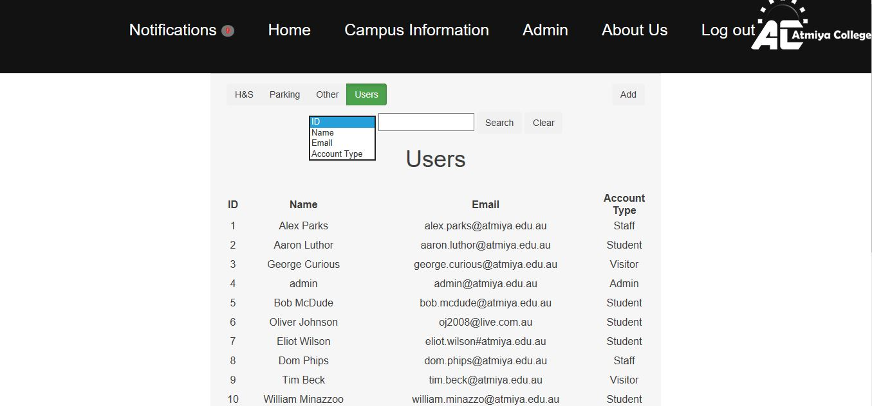

Story 11, Simple Payment forms, acceptance criteria is fulfilled because a user/student (in this case Aaron Luthor) has a payment getaway (in the form of “Pay Fine” button) in their profile next to violation that links straight to the payment webpage, and this what the acceptance criteria specified and what the website achieves.

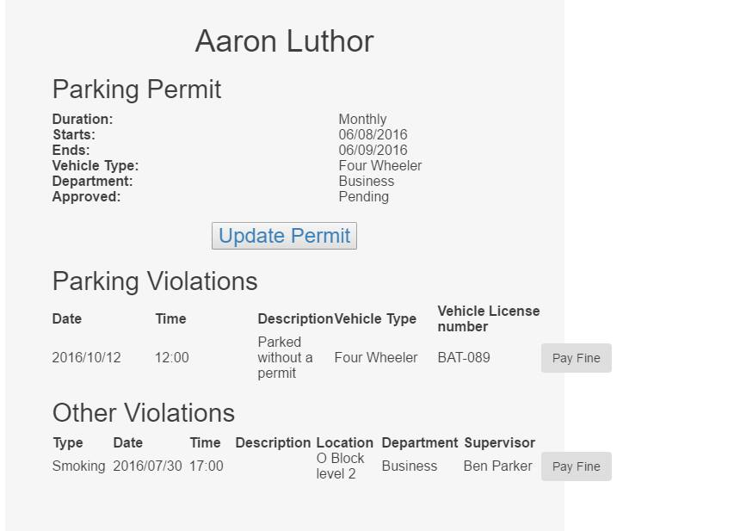

Story 5 Parking Permit Payment acceptance is fulfilled because you can choose payment options including Visa and MasterCard.

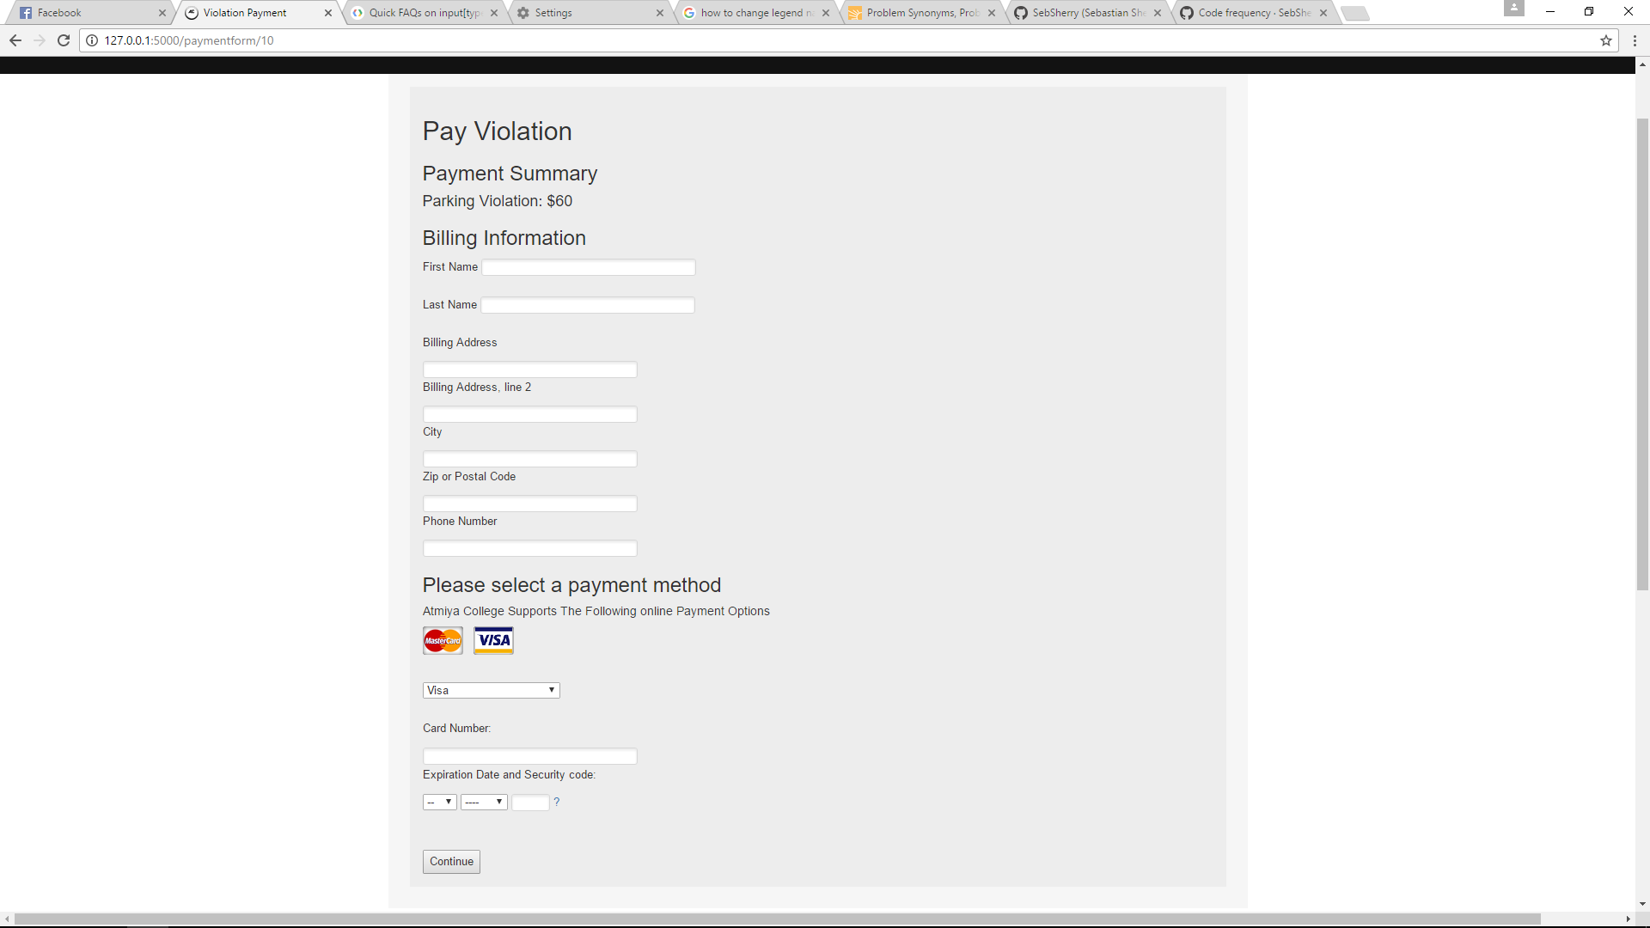

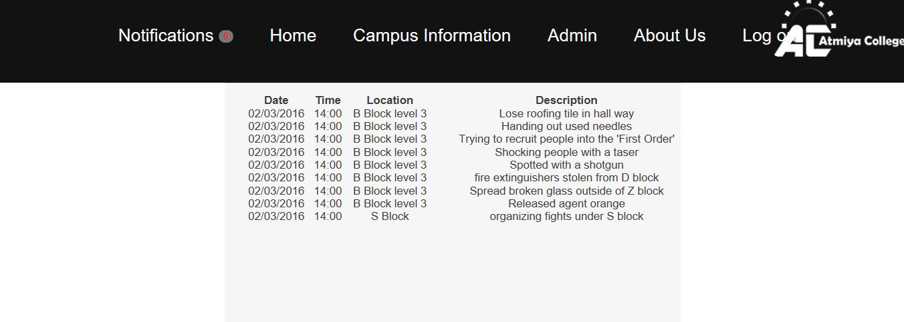

To check that notifications work, I logged as a permit holder Aaron Luthor, and clicked on notifications bar, emergency/notifications updates are given, as described in the acceptance criteria story 25, emergency updates.

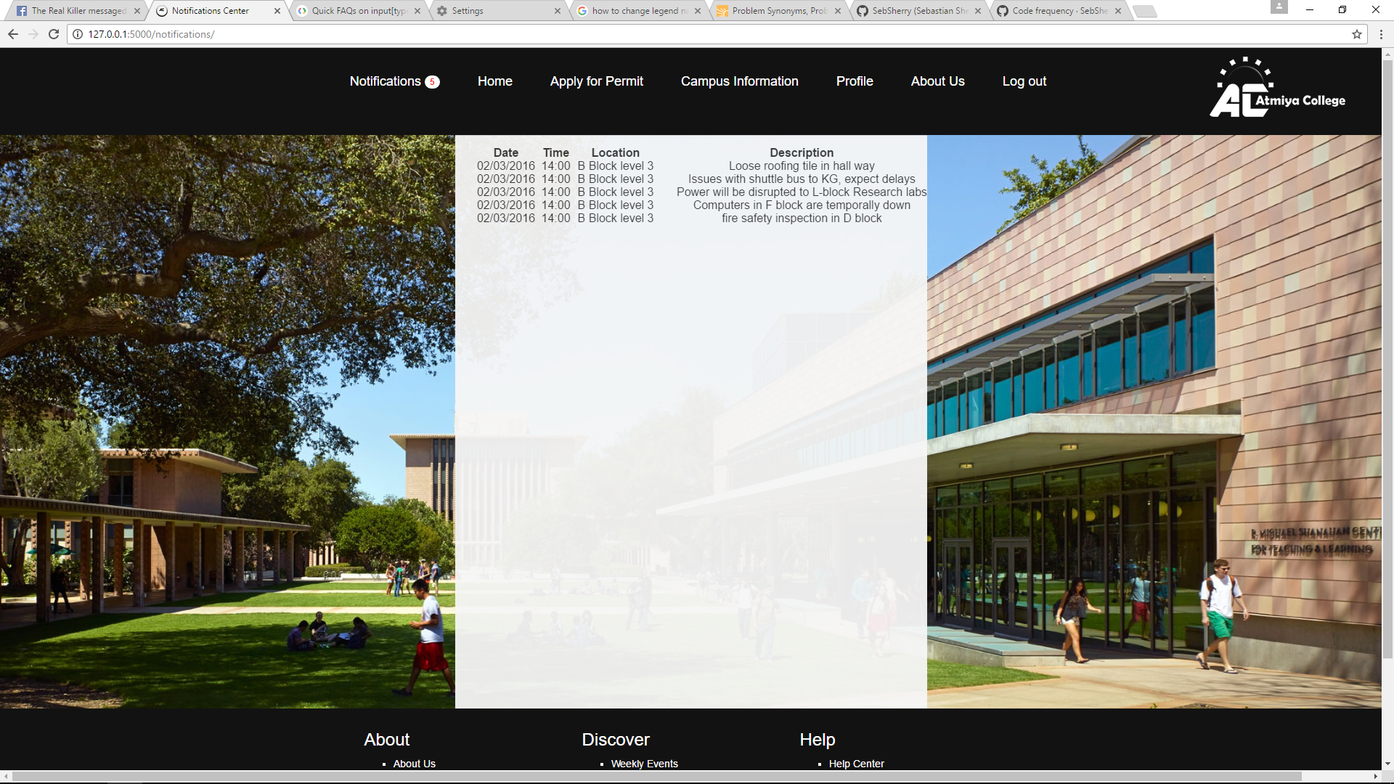



Though this screenshot shows only some of the email functions, all the acceptance criteria that incorporate were tested and fulfilled. The examples included in the example below include parking violation updates and overdue fine payment notifications.

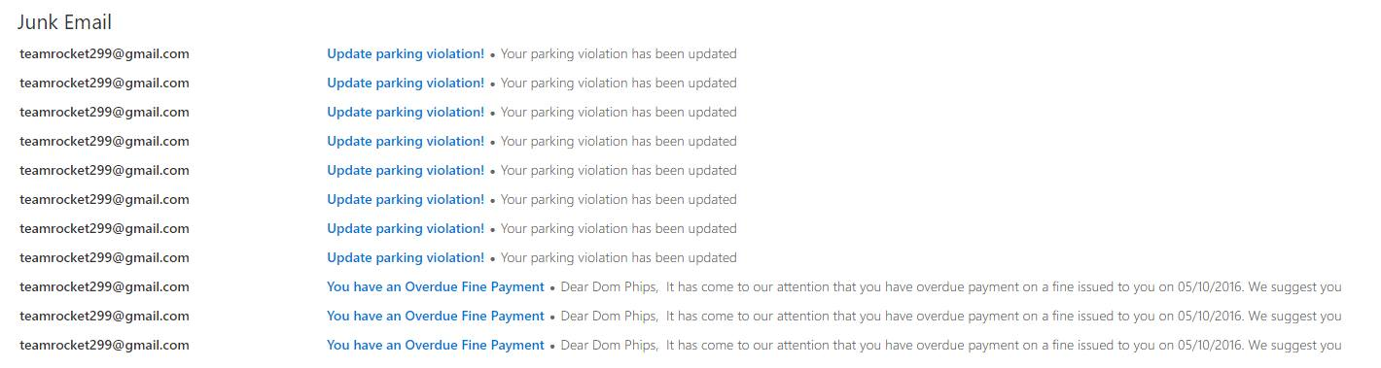

Story 1 has been fulfilled because admin can add rules to the rules and regulations page.

* logged in admins can click on the rules and regulations page and chose to add rules

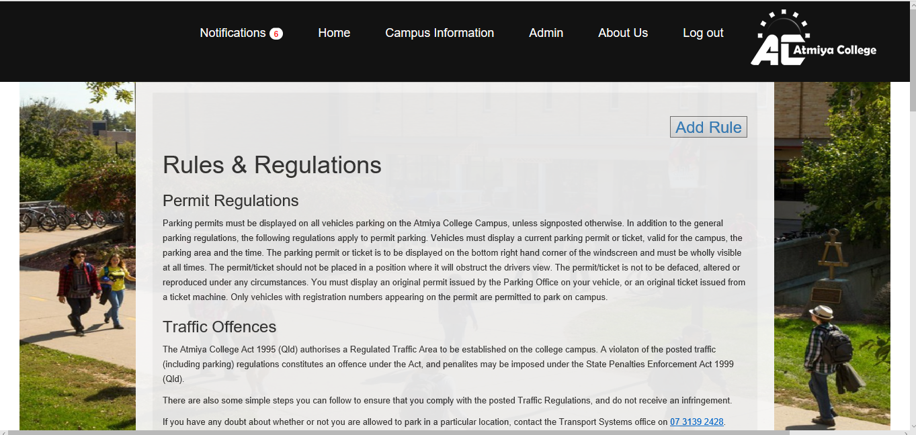

*Admin can fill out the form below and add rules into the database

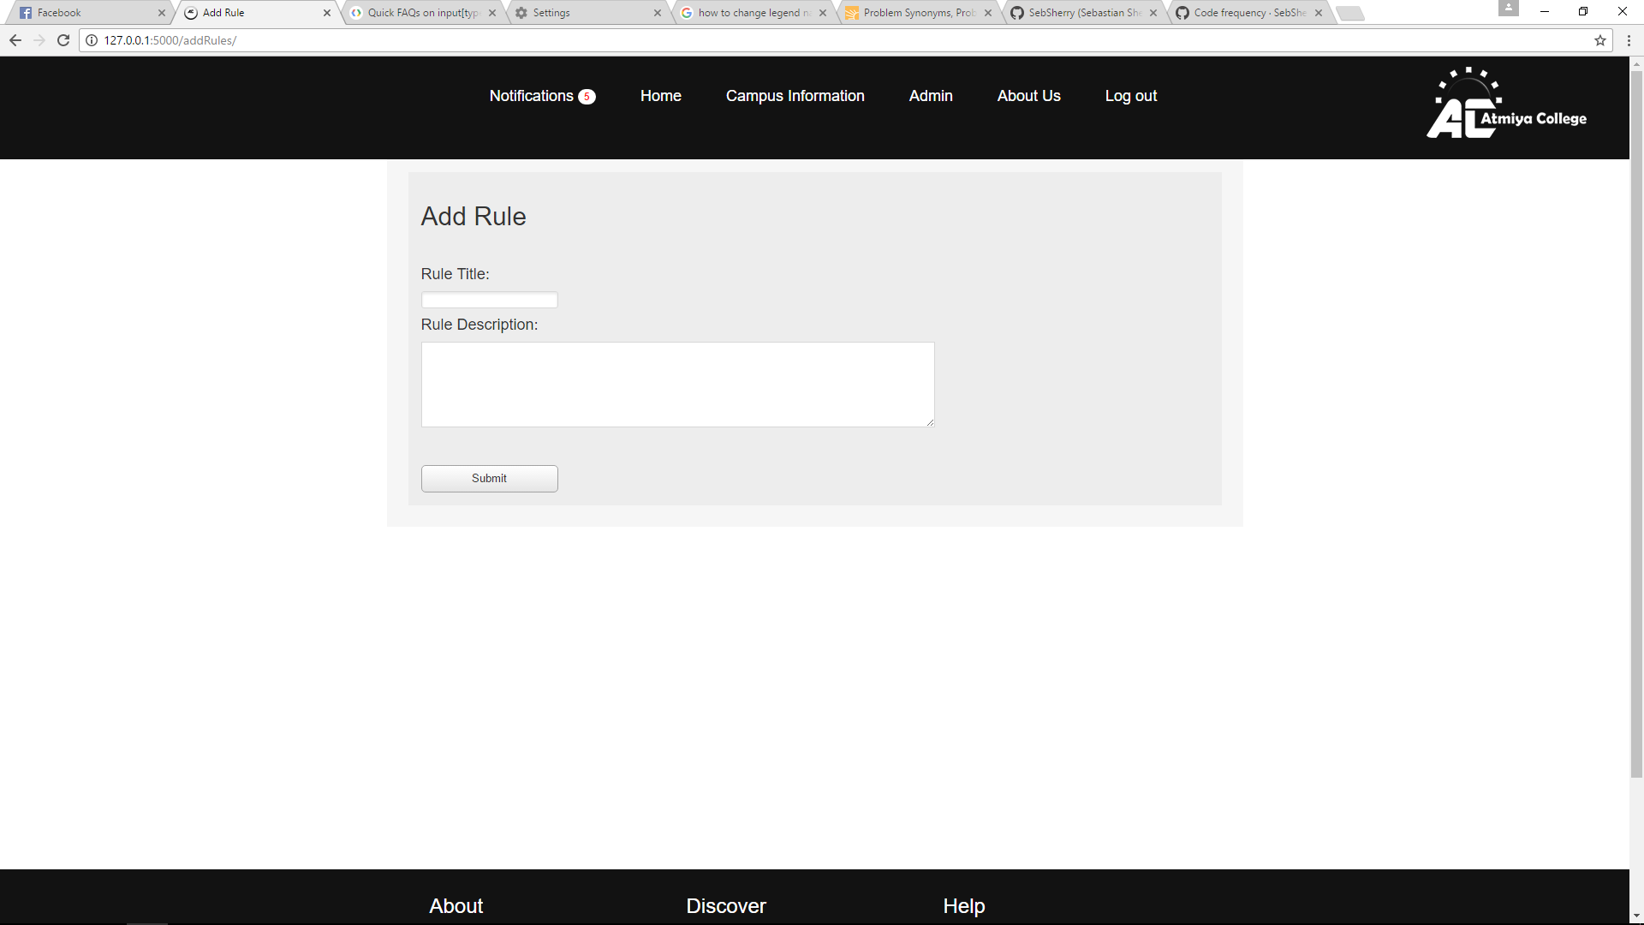

Admins can also update existing rules

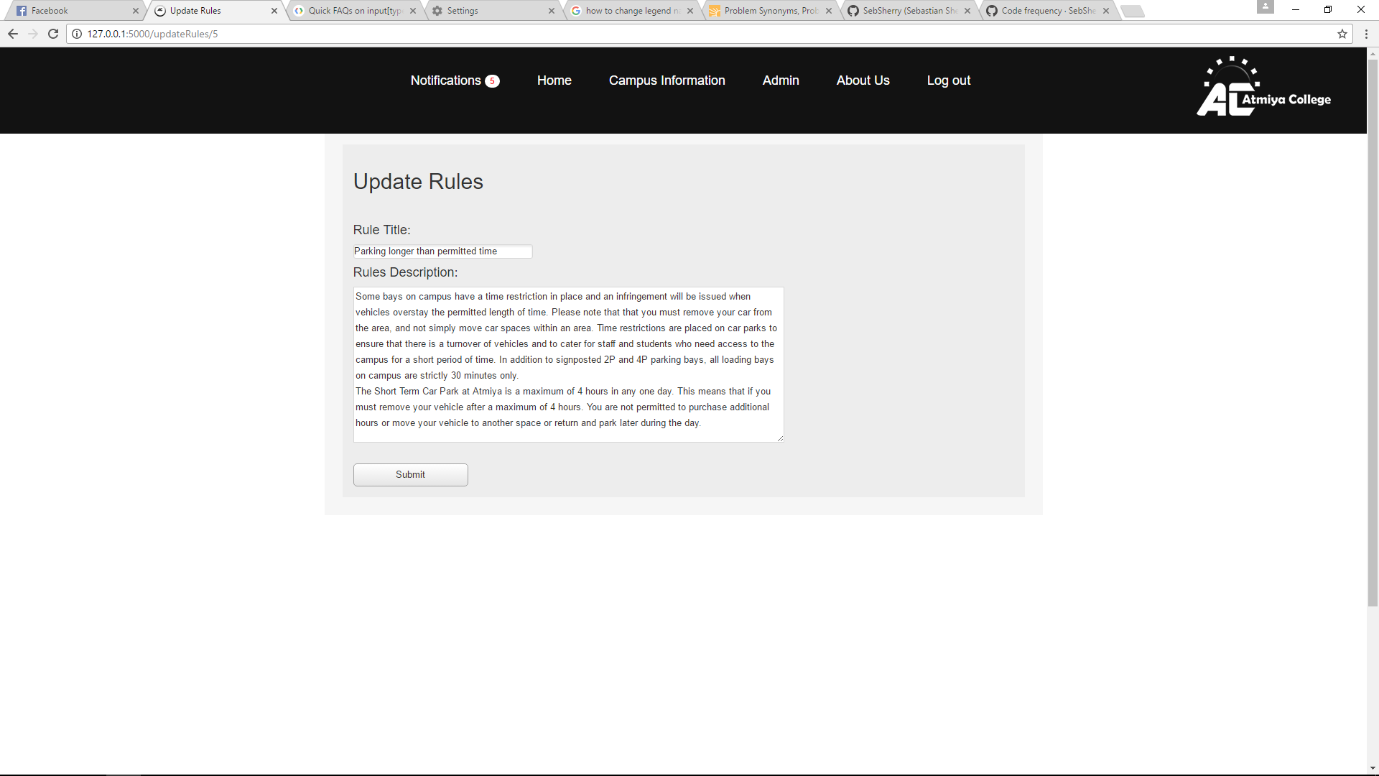

For a demo, I made a handicap rule. After I submitted it took me to the rules page. It worked, and I can update and delete rules I want.

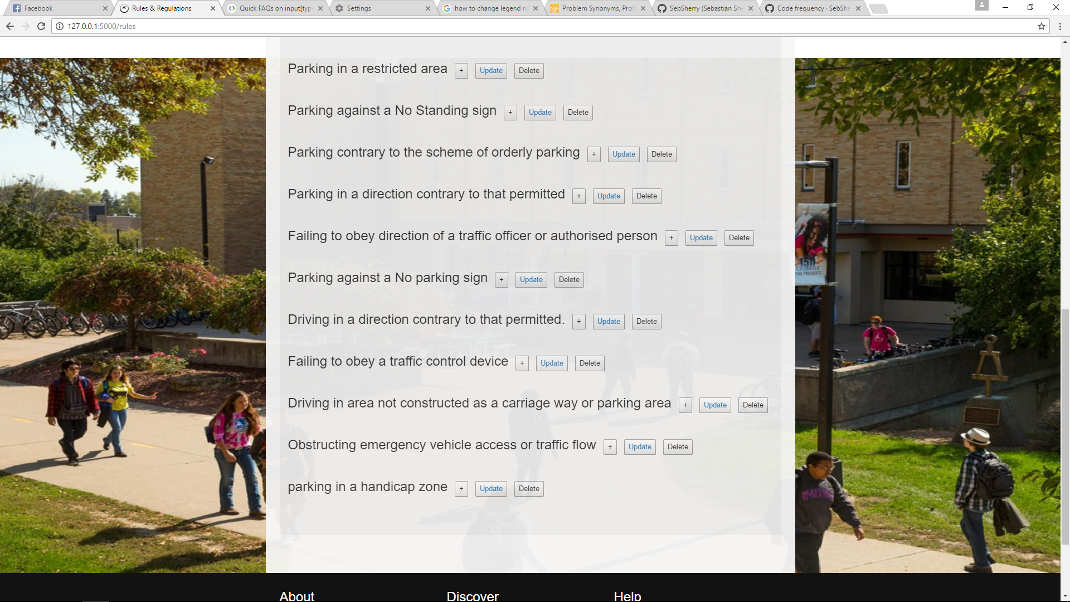

This story exceeds the acceptance criteria as it even has a confirmation box to ensure rules are not accidentally deleted.

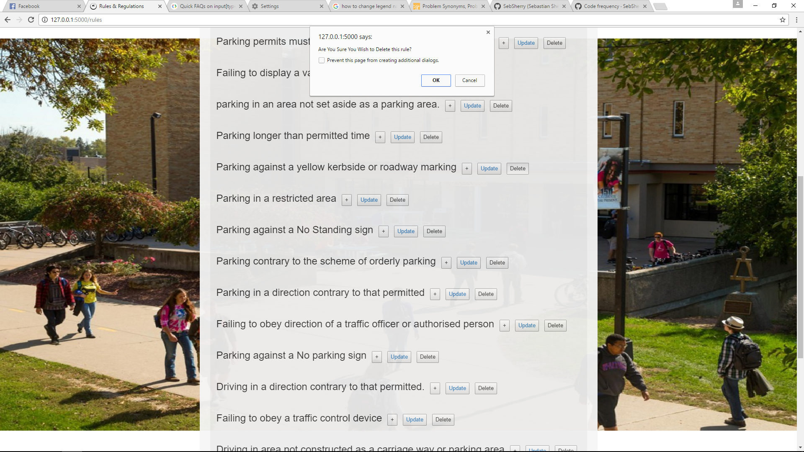

**Story 10: Educating patrol officer**

Patrol staff and admins receive a notification when the rules have been updated or new rules added so they do not submit incorrect violation.

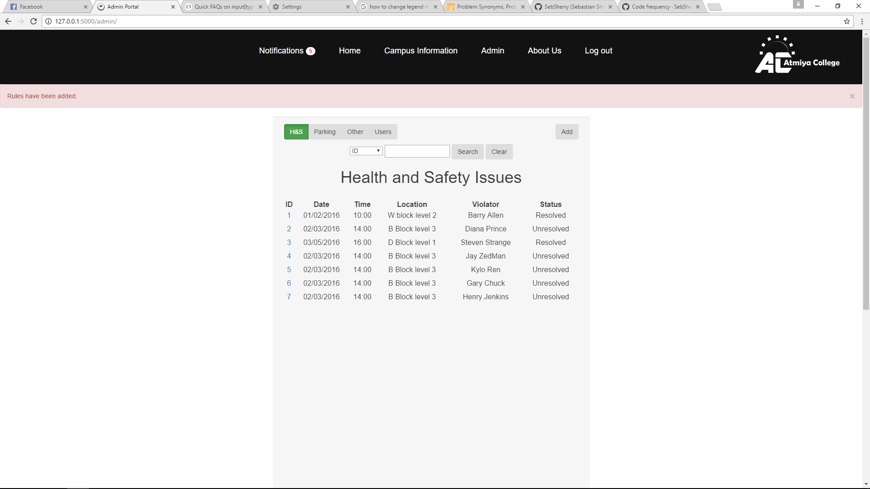

**Story 17**

Regular updates acceptance criteria because both permit holders and patrol staff are notified of rule changes when they occurred.

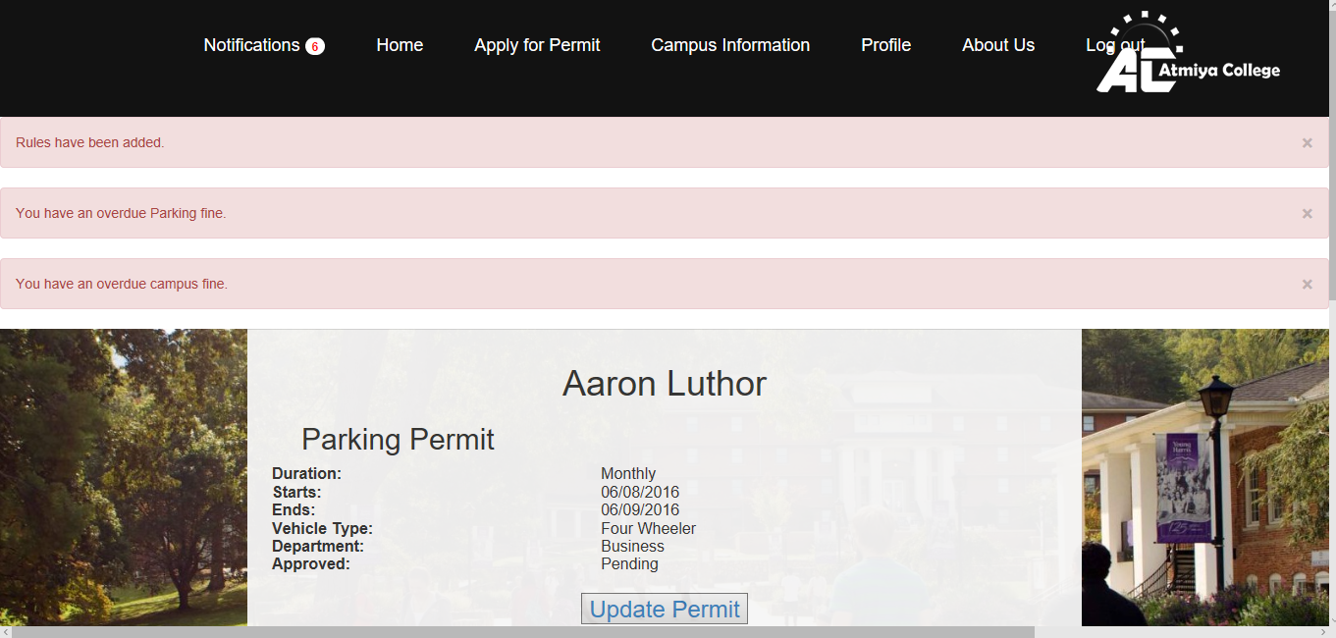

**Story 14**

Violation notification acceptance criteria is fulfilled because permit holders are notified when they receive new violations/fines and what type of violation they are.

